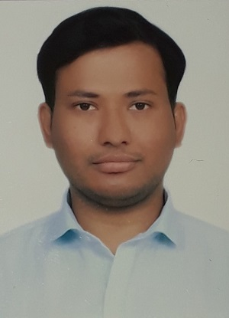

Mr. Rishabh Singh did his B.Tech. from IMS Engineering College ,Ghaziabad (Under Dr. A.P.J Abdul Kalam Technical University Lucknow) India and M.Tech. from Rabindranath Tagore University Raisen (MP), India. He is work-ing as a Lecturer in the department of Mechanical Engineering at Mahamaya Polytechnic of Information Technology, Anaugi , Kannauj (U.P). His area of interest are Fluids and Thermal Engineering. Contact: rishabh.singh725@gmail.com  
+91 8512838769