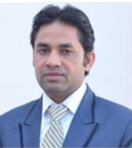

Dr. Uday Singh did his M.Sc from C.S.J.M University,Kanpur and M.Tech from IIT Bombay. He also completed his Ph.D from GLA University Mathura(UP). He is work-ing as a Lecturer in the department of Applied Sciences at Mahamaya Polytechnic of Information Technology, Anaugi , Kannauj (U.P). His areas of interest are Particle Physics and Solar cells. Contact: theudaysingh@gmail.com  
+91 976001679