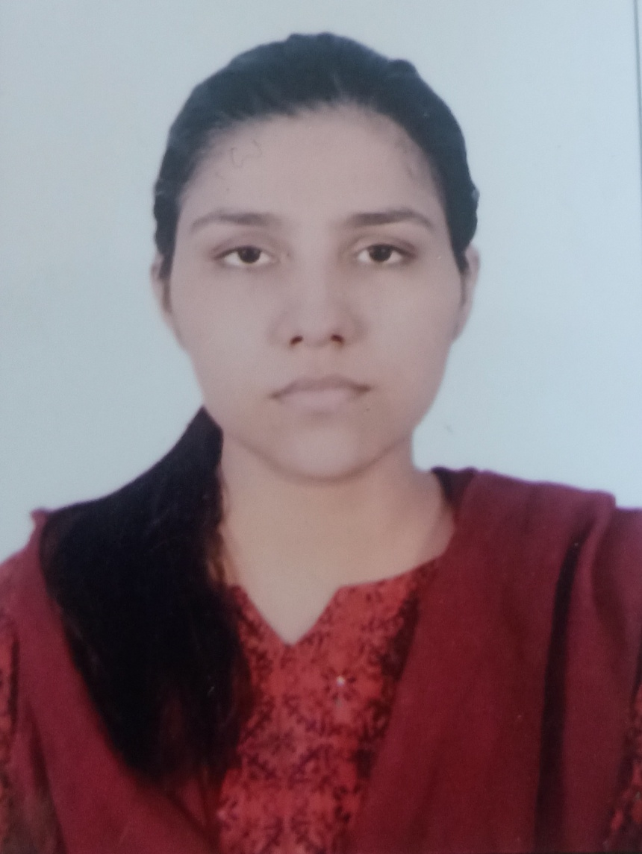Ms. Maria did her B.Tech and M.Tech from the central university Jamia Millia Islamia, New Delhi, India. Currently she is working as a lecturer in the Department of Mechanical Engineering at Mahamaya Polytechnic of Information and Technology, Anaugi, Kannauj (U.P). Her areas of interest are Design and Thermal Engineering.

Contact: mariasyed551@gmail.com