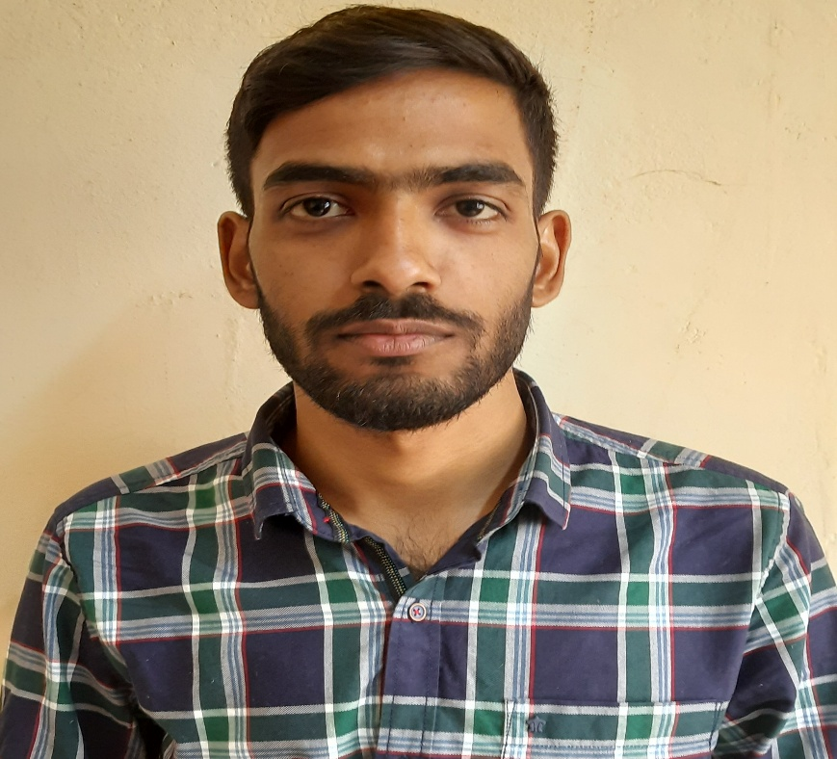

Mr. Anshu nigam did his B.Tech. from Kamla Nehru Institute of Technology (Under Dr. A.P.J Abdul Kalam Technical University Lucknow) India. He is working as a Lecturer in the department of Electrical and Electronics Engineering at Mahamaya Polytechnic of Information Technology, Anaugi , Kannauj (U.P). His area of interest are Communication Engineering and Control System.  
Contact: nigam3659@gmail.com  
+91 7985649396